# Devil Inc. Ltd. Weboldal drótvázterv

# Created on March 01 2020

# Table of Contents

1.0. Devil Inc. Homepage + Product List

2.0. Devil Inc About Us

3.0. Devil Inc. Contact Us

# 1.0. Devil Inc. Homepage + Product List

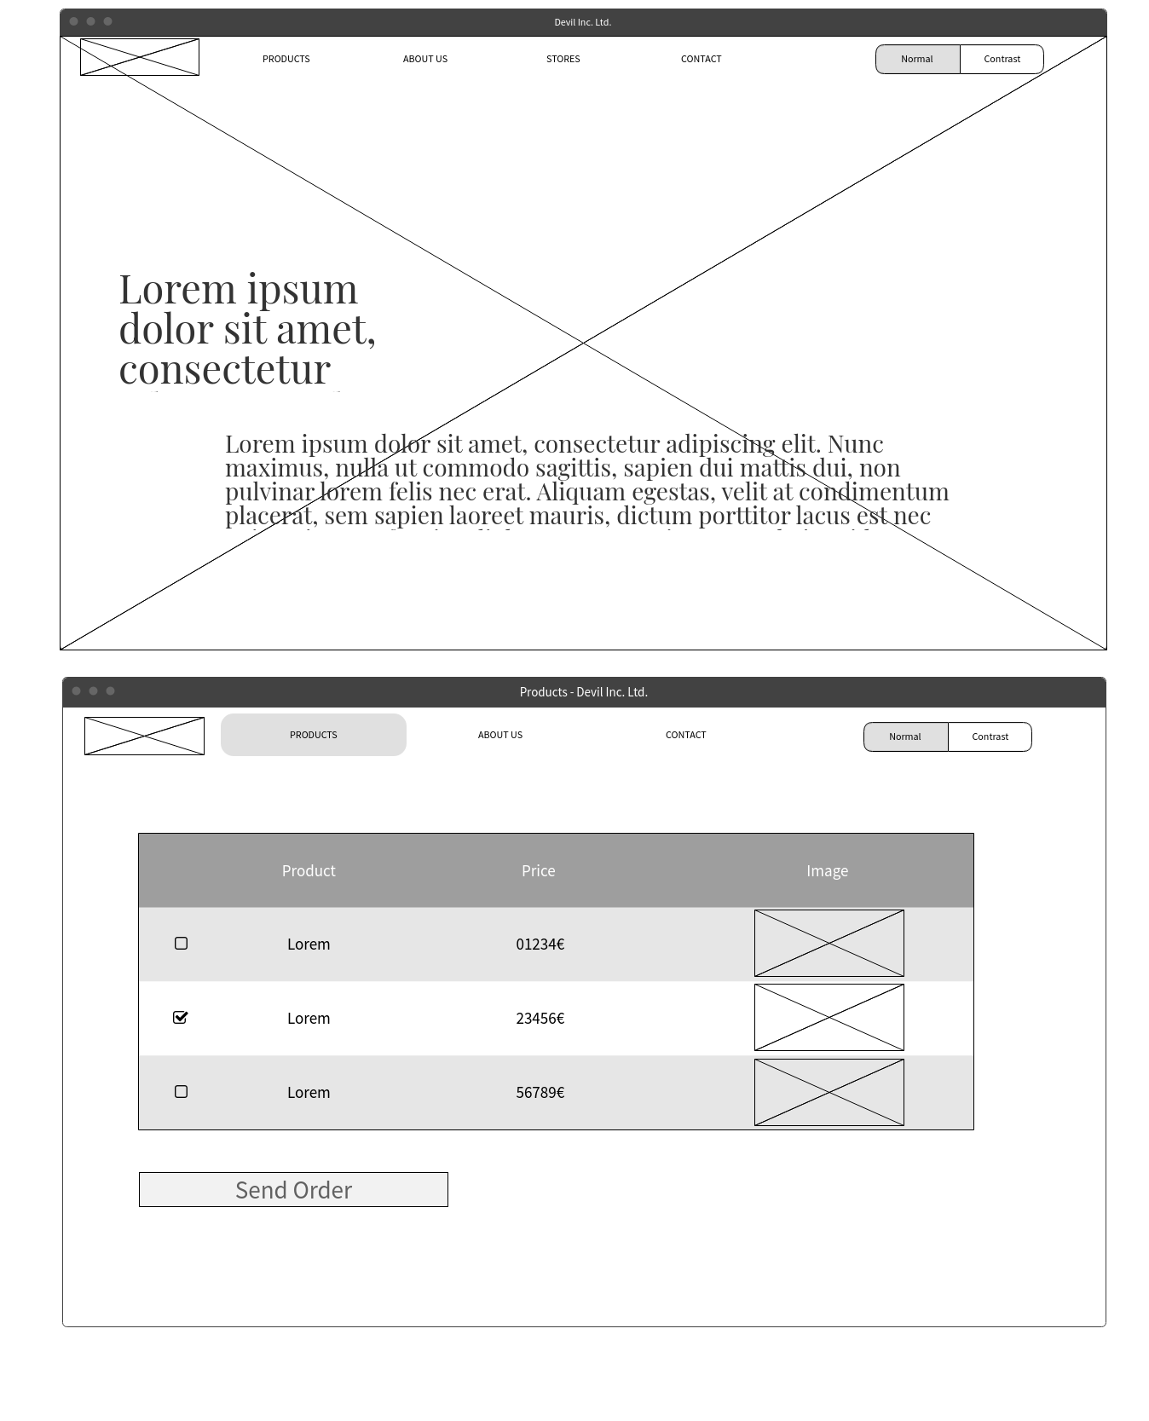

# 2.0. Devil Inc About Us

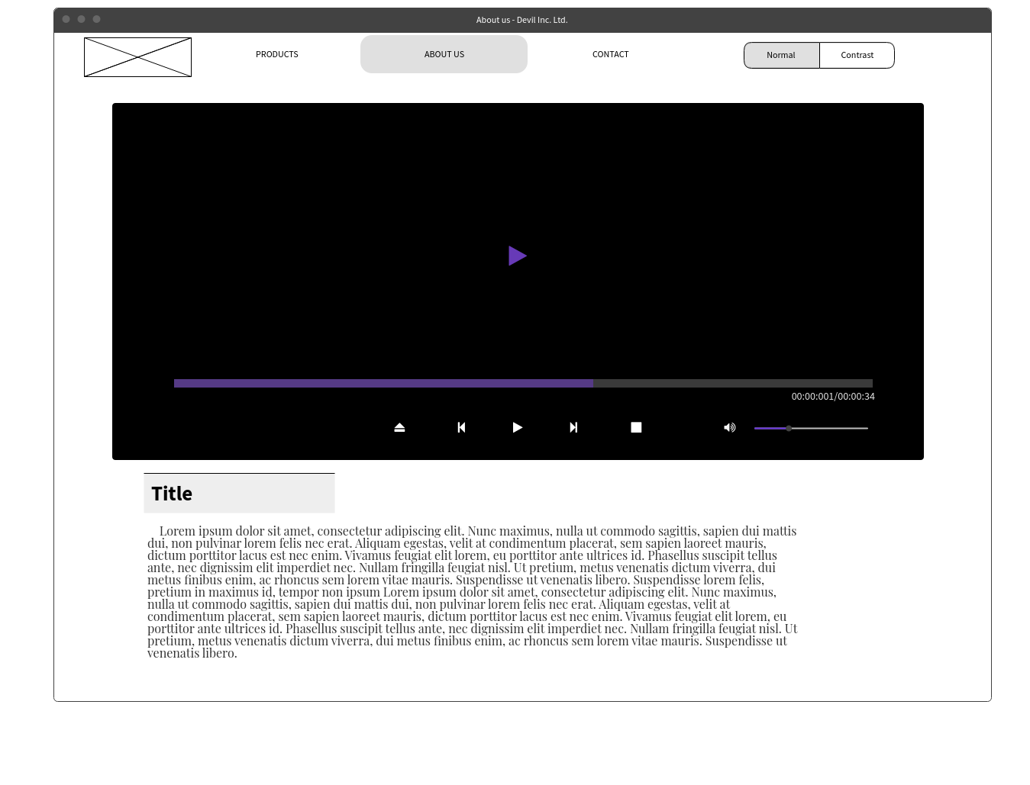

# 3.0. Devil Inc. Contact Us

